Welcome to <Your Group name> Scout Group

Thank you for taking on a role in Scouting!

You are joining the most successful youth movement the world has ever seen. Scouting was one of the outstanding success stories of the 20th century and continues to grow in the 21st century. From a gathering of 20 boys on Brownsea lsland in 1907 our movement has had over 300 million members worldwide.

When you start a new job, someone will usually tell you about the company you have joined, where you fit in, what is expected of you and where you can gain the skills necessary to do your job. Taking on a role in Scouting is no different and that’s the aim of this document!

Scouting aims to provide life changing adventure to all its members. We believe in helping young people fulfil their potential by working in teams, learning by doing and thinking for themselves. All this is made possible by the efforts of our dedicated team of hard working voluntary adults.

As an adult working with young people you have a unique role to play in their lives. Over time you will meet young people who will benefit from the fun and adventure they have had while in your care. They may not say thank you today, next week or even when they leave but throughout their lives they will remember and use the skills and fun they had as a Scout!

We don’t expect you to do this on your own, you will receive training and support in your role.

Yours in Scouting

??? Group Scout Leader

INSERT PICTURE HERE

Contents

Introduction and Purpose 3
What is Scouting? 3
Our Group 4
The Group Executive Committee 4
District/County 5
Sections 5
Volunteering with Scouting 6
Our Appointments Process 6
Stage One: Application 7
Stage Two: Approval 7
Stage Three: Appointment 7
Training for leaders 8
Module 1: Essential Information 8
Module 2: Your Personal Learning Plan 8
Module 3: Tools for the Role (Assistant Section Leaders & Section Leaders) 8
Training for committee members 10
Keeping you in the loop 10
Your Induction 11
Discuss your new role in Scouting in detail 11
Identifying the support you need 11
Making plans to get support 12
Have a go at the role 12

Introduction and Purpose

This document is designed to give you a brief overview of scouting and provide a guide to your first few months in the movement. It will also give you an idea of the types of support available to you and will hopefully answer some of the many questions you are likely to have.

If you ever have any questions please ask. Remember at all times we are part of a team, the others in it are our best resource, ask lots of questions.

We hope that after reading through this guide you will:

- Feel welcome and comfortable as a new member of Scouting
- Get excited about our programme
- Start to learn more about Scouting or history and traditions
- Know how to access training and other learning opportunities that will help you develop
- Know about the many resources that can help you along your Scouting adventure.

Scouting is growing! To fulfil our promise of providing ‘life changing adventure’ for a whole new generation of young people, we need more volunteers than ever before. Our volunteers are talented, and they need to feel supported and know that they can add value from day one.

That’s why we want to ensure that our leaders, volunteer line managers and supporters have the knowledge, support, sense of commitment, and enthusiasm they need to thrive.

In order to support you in your role you can expect

- Welcome and Induction
- Adult Training
- Tools and Resources
- Ongoing Support
- Recognition and Review

What is Scouting?

Adventure is at the core of Scouting. Through adventure we challenge individuals so that they learn and experience new things that will enrich their lives. When a Beaver Scout wakes up the morning after a sleepover, or a Cub Scout has confronted their fear of heights, or a young Scout leads a hike, that is adventure.

Along the way there is great fun to be had, and badges to earn. Scouting uses badges to recognise a wide range of interests and skills and, more often than not, the badges reflect the effort a young person has put in rather than what has been achieved.

All this is part of what we call a Balanced Programme. This helps young people to learn about their community and the wider world, improve their fitness and health and develop their creative talents. It encourages them to enjoy adventure in the outdoors and develop their beliefs and attitudes against the backdrop of the Scout Law and Promise. For more information on the Programme, visit http://scouts.org.uk/home/

Being involved is exciting and through the everyday adventure of scouting, young people and adult volunteers regularly experience new challenges that enrich their lives. Scouting offers a diverse range of activities and opportunities that challenge young people to be the best they can be physically, emotionally, spiritually and morally. It is this that makes scouting unique.

Our Group

INSERT GROUP NAME currently has about ?? young people as members with ?? Leaders and an Executive Group of ?? volunteers.

The group is overseen the Group Scout Leader who is the line manager and responsible for the overall running of the group.

Each section is overseen by the Section Leader who is supported by a team of Assistant Leaders.

Adults can also take on the role of Occasional Helper who whilst not covered to run sessions on their own can assist the Leaders at camps/days out and section meetings.

The Group Executive Committee

This group meets 4/6 times a year to oversee the running of the group. They are headed up by the Group Chairman supported by Group Secretary and Treasurer, along with the other members of the committee. The Group Executive Committee plays a vital role in the running of a Scout Group. Executive Committees make decisions and carry out administrative tasks to ensure that the best quality Scouting can be delivered to young people in the Group.

They are there to do the following

- Comply with the Policy, Organisation and Rules of The Scout Association.
- Protect and maintain any property and equipment owned by and/or used by the Group
- Manage the Group finances.
- Provide insurance for people, property and equipment.
- Provide sufficient resources for Scouting to operate. This includes, but is not limited to, supporting recruitment, other adult support, and fundraising activities.
- Promote and support the development of Scouting in the local area.
- Manage and implement the Safety Policy locally
- Ensure that a positive image of Scouting exists in the local community
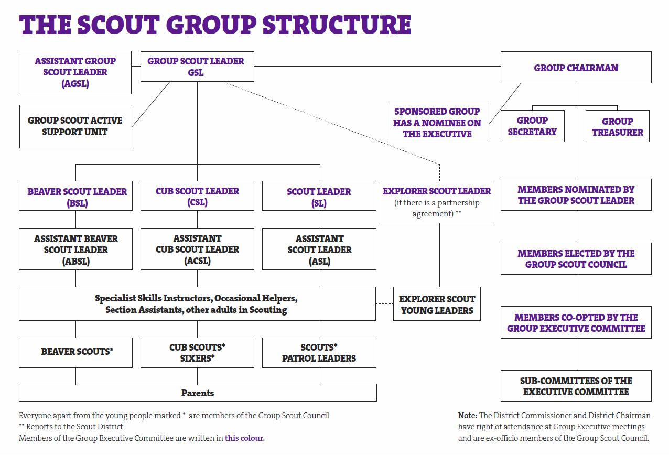

District/County

Scouting is divided up into counties and then Districts. We are part of the INSERT DISTRICT in INSERT COUNTY. The District and County have volunteers who are there to support and help us in what we do. They also both run camps and activity days that we try to attend.

Sections

 | NAME
 | Beavers are aged 5¾ to 8 they meet on a ??? night between ???. The current Beaver colony is run by BSL ??? supported by ABSLs, ???
 | Cubs are aged 8 to 10½ they meet on a ??? night between ???. The current Cub Pack is run by CSL ??? supported by ACSLs, ???
 | Scouts are aged 10½ to 14 they meet on a ??? night between ???. The current Scout Troop is run by SL ??? supported by ACSLs, ???

Volunteering with Scouting

Volunteers in Scouts come from all walks of life from the Duchess of Cambridge or Chief Scout, TV adventurer Bear Grylls to teachers, plumbers, shop assistants, businessmen/women, there is no such thing as a typical volunteer.

Scouting provides life-changing opportunities and adventure to both young people and adults. When someone talks to us about volunteering, we find a role that fits with their time and skills. If that means an hour a month, then we’ll work out how we can make the most of that. Most importantly, we’ll work hard to make that one hour enjoyable, meaningful and fun for the volunteer too.

Over the last few years it has been our mission to make it easier for adults to give as much or as little as they are able. It is how we change our society: many people doing a little bit.’

Adults in Scouting support the Movement in the following ways:

- Working directly with young people as Leaders, Assistant Leaders, Section Assistants and parent helpers
- Supporting other adults as volunteer manager (i.e. Group Scout Leaders and Commissioners)
- Looking after the administrative side of Scouting as Chairs, Secretaries, Administrators and Treasurers etc.
- Supporting scouting as members of Scout Active Support Units, Skills Instructors, Activity Advisers, Trainers etc.

Our Appointments Process

Before any adult appointment in Scouting can be confirmed we must be satisfied that the person taking on the role is a ‘fit and proper’ person’ to work with young people. To help us do this we have a simple appointments process which is made up of three stages, these are:

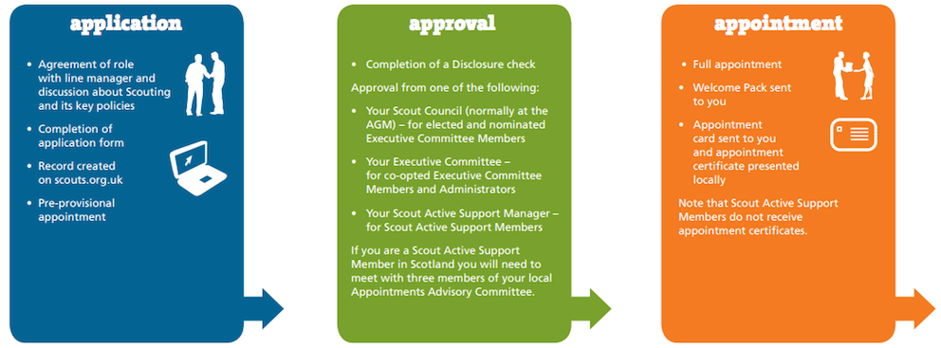

Stage One: Application

You will be given a couple of forms for you to fill out. One for your basic contact details and another for a check with the Disclosure & Barring Service (DBS). You will be required to show your identity documents and provide references.

During this stage you will begin your new role in Scouting. Please remember that if you are working with our young people, you can start to get involved immediately but only in a supervised capacity for now, as it is the policy of The Scout Association that unsupervised access to young people is not permitted until a clear Disclosure & Barring Service (DBS) certificate has been received.

Stage Two: Approval

Once we have received your cleared DBS check you will be invited to a short meeting with an Appointments Panel. The purpose of these meetings is for the panel members to satisfy themselves that all adults applying for a role in Scouting are suitable for the appointment. After the meeting the panel will make its recommendation (normally that evening), regarding their decision to grant your adult appointment. Soon after you will receive notification of the panel’s decision; you will also receive a certificate of provisional appointment.

Stage Three: Appointment

Once your appointment has been approved, you will then move to the appointment stage of the process. To support you in your role The Scout Association provides training that builds upon your existing skills, knowledge and experience. The training you will receive will depend on your appointment (leader, manager or supporter), and is intended to give you additional skills and knowledge to ensure that you carry out your role to the best of your ability.

You will be given a Yellow Card that outlines the safeguarding code of practice that the Scout Association work to, this is important and you should read it and ideally keep it with you when undertaking Scouting activities.

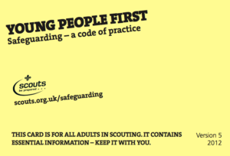

You will also get a Purple card which outlines how to run safe activities and what do in an emergency

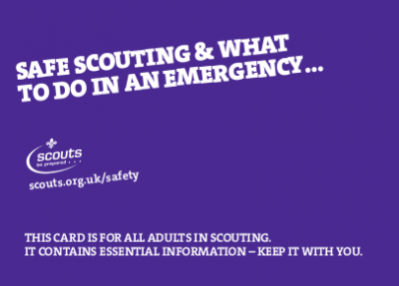

Training for leaders

Getting started Training, for section assistants, assistant section & section leaders, group scout leaders & commissioners, involves completing three short modules designed to introduce you to your role and to start you planning for the future.

Module 1: Essential Information

This module contains basic information that all adults involved in scouting need to know. It’s a simple informative module and can be completed by either attending a training session or via online e-learning.

Module 2: Your Personal Learning Plan

To support you in your role The Scout Association provides training that builds upon your existing skills, knowledge and experience. The training you will receive will depend on your appointment (Leader or Manager), and is intended to give you additional skills and knowledge to ensure that you carry out your role to the best of your ability.

Shortly after your meeting with the Appointments Panel, you will be introduced to your Training Adviser. Your Training Adviser’s role is to discuss our adult training scheme with you in more detail, tell you about the training you are expected to undertake, help you identify the modules you need to complete and support you through your training.

This sounds a lot worse than it actually is. There are a number of methods available to help you complete your training and with you Training Adviser will identify your training needs and agree with you a Personal Learning Plan (PLP), which will fit into your day-to-day life and Scouting commitments.

Module 3: Tools for the Role (Assistant Section Leaders & Section Leaders)

This contains the basic information about the role you have agree to take on, and practical help for working within the group.

Once you have completed the Getting Started modules your full appointment will be confirmed and you will be insured to run sessions.

An overview of the adult training scheme and the modules you will need to complete can be found in our Module Matrix.
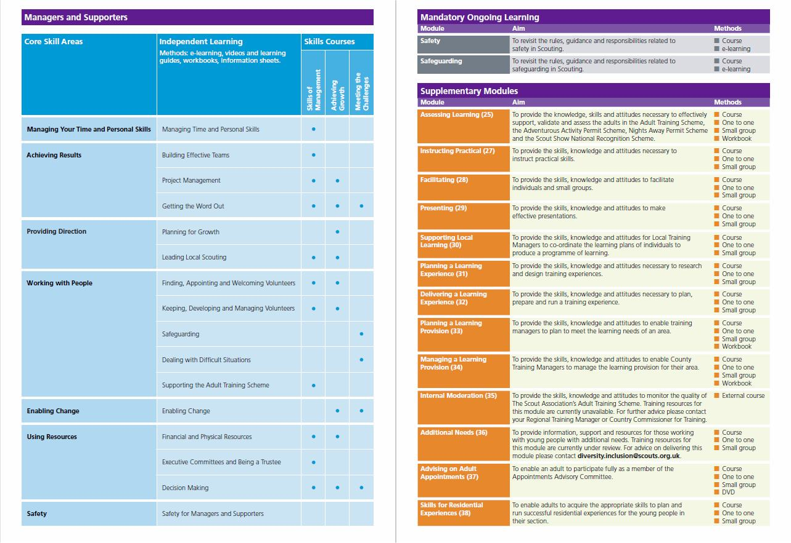
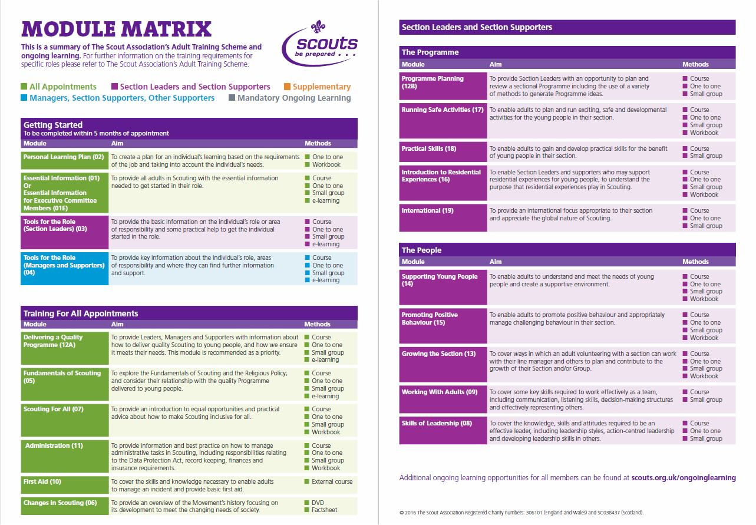

Training for committee members

Getting started Training, for executive committee members, administrators & supporters, involves completing Module 1E: Essential Information.

01E: Essential Information for Executive Committee Members

Essential Information for Executive Committee Members is a mandatory module that covers the Fundamentals of Scouting, but also provides more specific information on the responsibilities of Executive Committee Members, enabling them to carry out their role effectively. This module covers:

- The Fundamentals of Scouting
- Executive Committees and trusteeship in Scouting
- Safety in Scouting
- Safeguarding - child protection

Keeping you in the loop

Once your appointment has been made full you will be able to register and login to our national adult membership database, this is called Compass.



Using Compass, you will be able to see your role status, training records, awards and event invitations. You can also choose what communications you would like to receive.

You will need to register at https://compass.scouts.org.uk/login/User/Register before you can login. Once registered you can login to Compass at www.compass.scouts.org.uk

We will use the information you provided on your Adult Information Form to set-up you membership record and keep in touch with you.

If your contact details change:

Please remember that it is your responsibility to keep your personal details up to date on the database. So, if your contact details change, remember to let us know! You can edit your details yourself by logging on to Compass. This will ensure you receive the information you need, are kept up to date and informed of what’s going on.

If you need any help using Compass please speak to your line manager or visit the Compass user guides at http://compasssupport.scouts.org.uk/

Your Induction

Now that you've said 'YES'

Most people will be asking themselves all sorts of questions. For example

- "What have I let myself in for?"

- "Have I got any useful skills to offer?"

- "Will I get the hang of it?"

- "Can I ever be as capable as the other adults?"

- "What needs to be my first step?"

Don't worry, such questions are quite normal, but they do suggest that, like the rest of us, you need support. Whether you are going to be working with young people, leading other adults or supporting a the group in another capacity, we cannot expect you to be able to get started on your own.

The first few weeks are challenging whenever we tackle something new. It is this period when we are finding our feet and when plans for the future are laid. It is clearly a very important time and deserves time and effort. The key elements are:

Discuss your new role in Scouting in detail

There is only one way to do this. It involves a face to face discussion, usually this will be with your volunteer line manager or the person who recruited you. Together you can discuss your new role in details and identify the support that you will need to get started. As a starting point take a look at the role decscritions on the following links

- Section Leader – Beavers. Cubs, Scouts
- Assistant Section Leader – Beavers, Cubs, Scouts
- Section Assistant – Beavers, Cubs, Scouts
- Group Scout Leader
- Executive Committee Member
- Group Chairman
- Group Treasurer
- Group Secretary

Identifying the support you need

When starting something new we all need support. Experience tells us that at the start, support probably comes under the following headings:

- Information to help you understand Scouting,
- Meeting other people,
- Contributing existing knowledge, skills and experience,
- Learning and using practical skills,
- Personal support and encouragement.

When you have discussed and listed the needs for each area, your supporter will then be in a position to help you make some plans.

Making plans to get support

The lists of needs that have evolved during your discussions now need to be turned into a support plan. Against each need detail?

- How each need will be met the METHOD,
- What is to happen the ACTION,
- Who will do it by WHOM,
- When it will happen by WHEN.

Although it seems a little formal at first, making plans in this way is a very effective and reassuring way of planning support. It makes sure that both of you and others involved know what is needed, how support is to be provided, by whom and by when. It avoids confusion and allows you have say in your own progress.

Try to prioritise the items on the support plan so that initially you concentrate on the things that are most important. Both you and your supporter should share the responsibility for taking action. If all of the responsibility is placed on one person, that person can get overloaded while the other gets frustrated by the lack of progress.

The plan can be used to meet and get support from different people in Scouting. This will help you to make friends with new people and feel that you belong. It also helps share the load of providing support. But remember Scouting has a responsibility to support you if you are to help Scouting.

Making and carrying out the support plan is only part of the process. Getting together with your supporter to review how things have gone is just as important.

To help you, at the end of this section, we have provided a suggested list of areas of support you could benefit from (with time scales), during your first five months.

Have a go at the role

Nothing boosts people's confidence more than achieving something. This is particularly true for new adults in Scouting as it helps establish credibility with the other members of the team, the young people and/or other adults and most importantly with themselves.

It makes sense to find something with which you are familiar and, if possible, is something fresh and new to those who you are working with. Running a game that you are familiar with but which is new to the section you are working in may be ideal. You will have the confidence of knowing the game and the members or the section would have something fresh and will not compare you with whoever usually does that game.

Basing an activity around a hobby or interest is another useful way to get started; such as collecting, modelling, cooking or fishing. If you are a newcomer who will be involve in Scouting in another way, working with a more experienced person on a bigger project may also work. This is often a good way of getting involved if you are very unsure.

But don’t forget if at any time you feel unsure or need help you can always ask the members of our team.

Good Luck!

INSERT NAME
Group Scout Leader
??? Scout Group
Email
Phone

